MENDOCINO COUNTY GETAWAY

August 4 – 6, 2017

With excitement in the air, our group of Vipers leaves the Castro Valley Bart Station and heads north to meet the rest of our group at Panera in Rohnert Park. Seth brought enough two way radios for our group and was kind enough to charge them each evening for us. Radios make an event more fun and easier to keep the group together. With his call sign of “Purple People Eater” he was our sweep in his Hellcat.

Traffic was light and once on the back roads, that are very well maintained, we had several opportunities to let our Vipers roar. And roar they did! Most road boulders were considerate and pulled over for our line of snakes with a purple tail. Lunch in Boonville was very good but slow service put us behind schedule as we set out for Greenwood Ridge Winery.
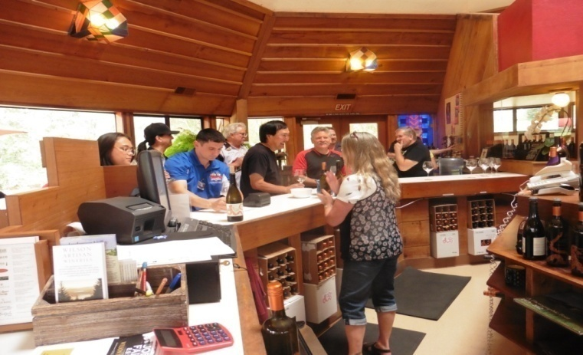
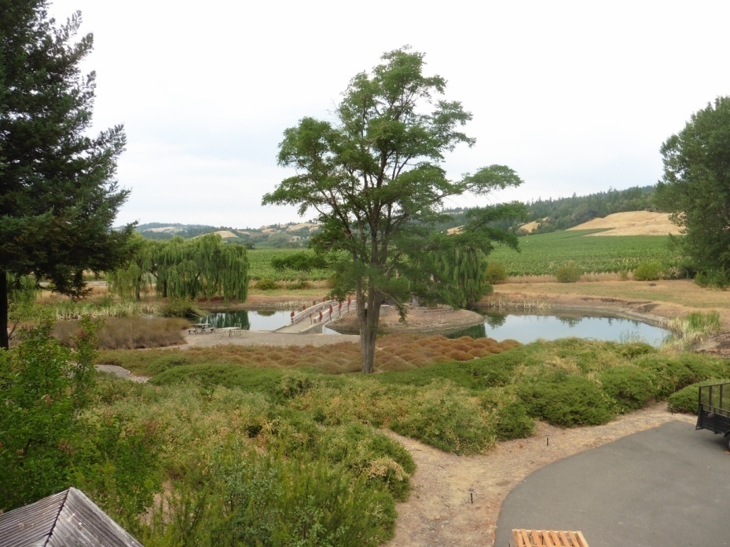
Rainbow, our pourer, met us and escorted the group into the beautiful redwood tasting room with an encircling deck overlooking a tranquil lake with a bridge to an island. The building was constructed from one giant redwood tree that had fallen on the property. With plenty of varietals to choose from members relaxed, visited and sipped. Our tasting was free because most of us bought some wine for our collections.

The drive up the beautiful Mendocino coast to Ft. Bragg was pleasant with cool breezes and great ocean views. Because of our lunch delay we bypassed Glass beach, gassed up and set out on our last leg of the day to Willits. Another scenic drive through the Jackson State Forest leads us to the Baechtel Creek Inn, our home for two nights.
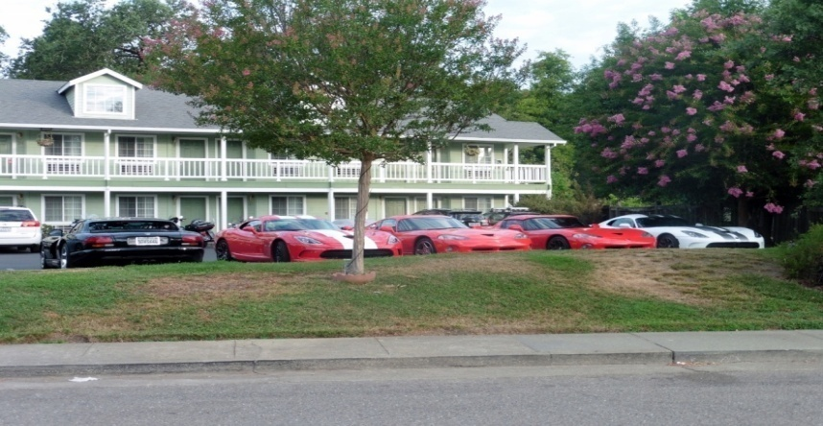
After washing off the road dust and a change of clothes our group drives south to Redwood Valley and the hilltop home of Maria and Rusty, owners of Testa Vineyards for our special dinner in the vineyards. We are greeted by the Chef Croux and his team and our hostess Amanda as our line of colorful cars fill the driveway.
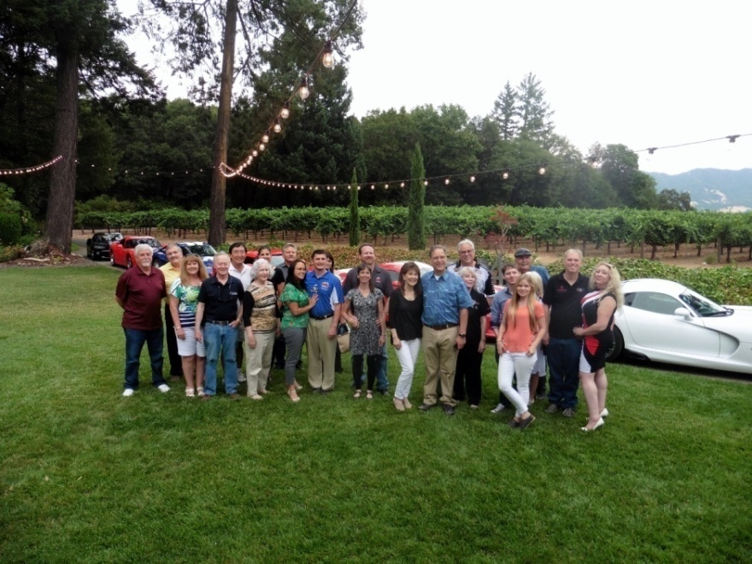
Kelly and her son Croux wowed us all evening with a large selection of appetizers and food. Appetizers were fantastic and included delights such as polenta fries with romesco sauce, bacon wrapped dates, cheeses, meatballs, olives, bruschetta and mango ceviche. Amanda explained and poured many different and distinctive varietals for us to try. All were excellent.

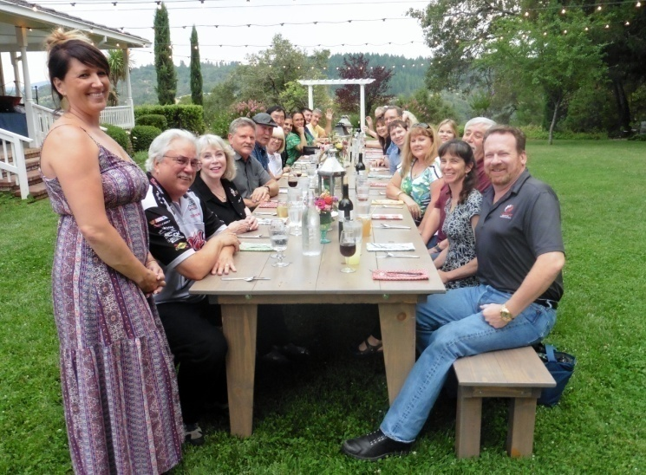
As dinner time approached, we made our way to a large table on the lawn by a water fall and pond to await the main courses. The salad was spinach and arugula with candied pecans, feta cheese, peaches and strawberries. The entrée featured grilled flat iron steak with chimichuri sauce along with salmon with pineapple and chicken skewers. All of this was accompanied by roasted “Potatoes of Love” and a corn and tomato salad. Wine flowed freely all evening and the finale was fresh strawberry pie with mini cheesecake bites. Wow indeed!
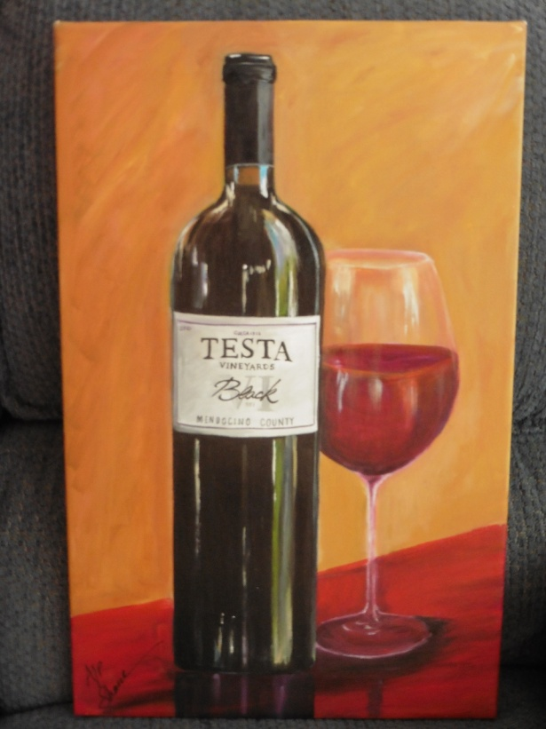
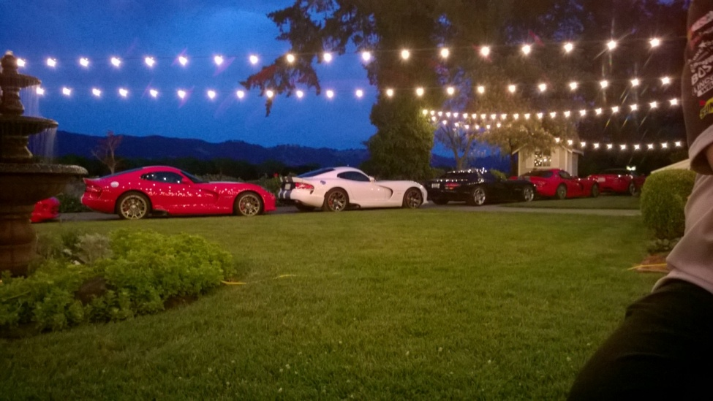
Maria, a fourth generation winemaker returned from the annual winemaker dinner with 2 gold medals – something she regularly does. The NorCal Viper Club presented her with a gift for hosting us and as a birthday present. Sheri Chakamian painted a beautiful Testa wine bottle for her. Many of you may know that one of her themes is wine bottles. The gift was truly a surprise and appreciated.

Full and tired from our exciting day we cruised back to the hotel. Unfortunately GPS doesn’t work too well in the area because a new freeway bypass was built. Some members took an extended tour but finally make it back to the hotel.

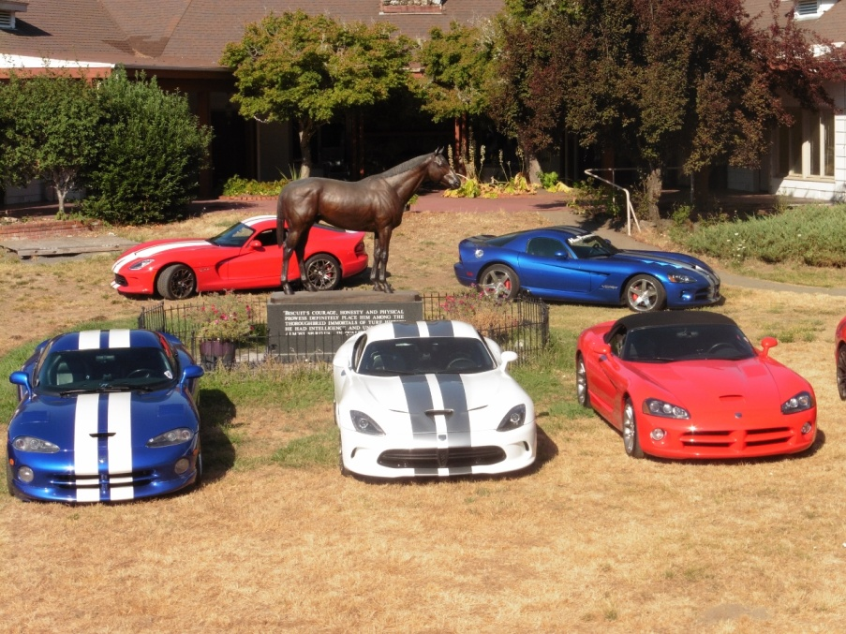
Day two began with a nice breakfast at the Inn before caravanning down Highway101 to Ridgewood Ranch, the home of the famous racehorse, Seabiscuit. Arriving early we position our Vipers around the bronze statue of Seabiscuit and take group photos. At Carl’s suggestion, we opened our hoods in a salute to Seabiscuit. We are met by Jacqueline, President of the Seabiscuit Heritage Foundation and Tracy our docent for the tour.

In the main hall we examine a large collection of memorabilia and then watch a movie about the Howard family, Seabiscuit, and his main jockey Red Pollard. Seabiscuit became a symbol of hope because of his underdog status during the Great Depression. His owner Charles Howard was a successful Buick dealer in San Francisco. Next we toured the Howard house and learned the history of the ranch.
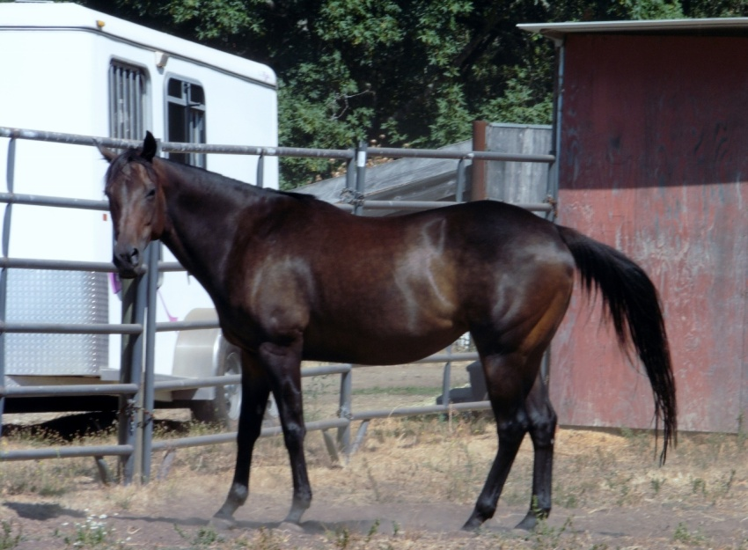
The walking tour takes us to the stud barn where the Stallions lived and then down a country road where we stop under a shade tree to listen to Tracy’s stories about the outlaw Black Bart who worked the area robbing Wells Fargo stage coaches. At the coral, Jacqueline introduces us to her saddle horse and two brood mares Bonzie and Giselle, Little Biscuits as they are called. The foundation is pursuing a breeding program to preserve the blood line.
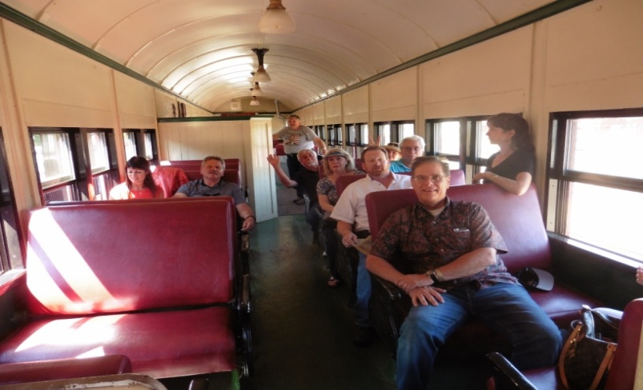
La Siciliana is our lunch destination back in Willits. After lunch we have time to rest at the hotel before our next activity – the Skunk Train. Arriving at the Depot early, we get our tickets and wrist bands and I meet our Engineer Jim and Adam our Conductor. ALL ABOARD ! yells Adam when it’s time to board the train. Because the Skunk Train added this train primarily for our group we had it to ourselves with only a few other passengers.

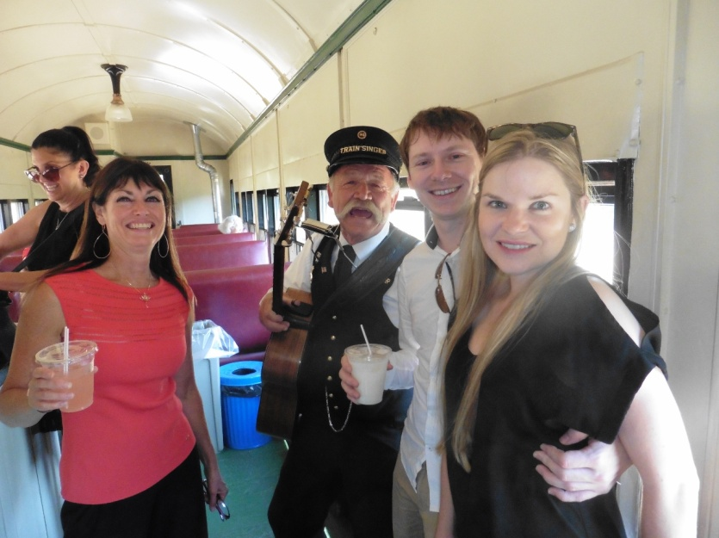
A line at the bar forms as soon as Pam our bartender arrives. With drinks in hand we wonder around the train from car to car. A popular car is the covered open observation deck. To complete the experience I ask that Greg the Train Singer join our group. As we chug along the tracks through town and into the redwood forest, singing and merriment breaks out in impromptu hootenannies.

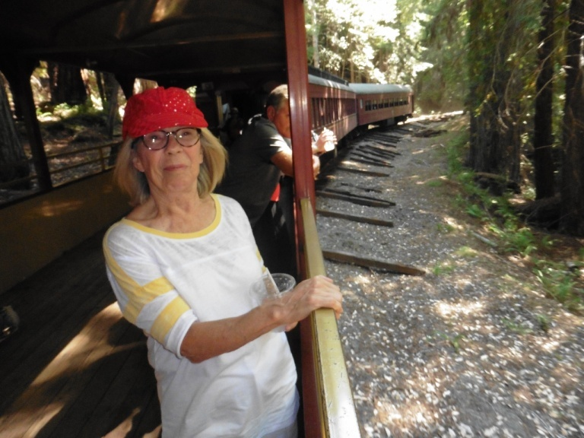
The leisurely journey takes us through a tunnel and over trestles by some old growth redwoods to our destination Northspur. At this peaceful stop in the redwood forest a wonderful BBQ dinner is waiting for us. As we visit, eat, drink some more, Greg serenades us with his guitar and harmonica. Returning to Willits about 8:00 P.M. we all bring some wine and snacks for a pool and hot tub party at the hotel that lasted well into the night.

Day three. After a late breakfast some members head for Mendocino, Tahoe, or home. The rest of us continue the fun by visiting the Jaxon Keys Winery and Distillery and have lunch in Hopland before saying our good byes and heading home. Everyone thanked us many times, we appreciate your kind words and cards; we thank all of you who attended and we’re glad you had a fun and memorable experience in Mendocino County.

Please see movie and photos of the event on the Club website.

